***Supply chain notebook***

This document outlines The steps of our project “Supply chain Analysis“ Using Powe bi. The project will progress through several stages: initially, the data will undergo cleaning and preparation. Following this, the key questions that the project aims to address will be identified. Finally, building dashboards by visualization and final report.

* ***Data cleaning and preprocessing Phase:***

1. Data Import and Inspection:

* Import dataset in CSV format and perform an initial review to understand its structure and content.

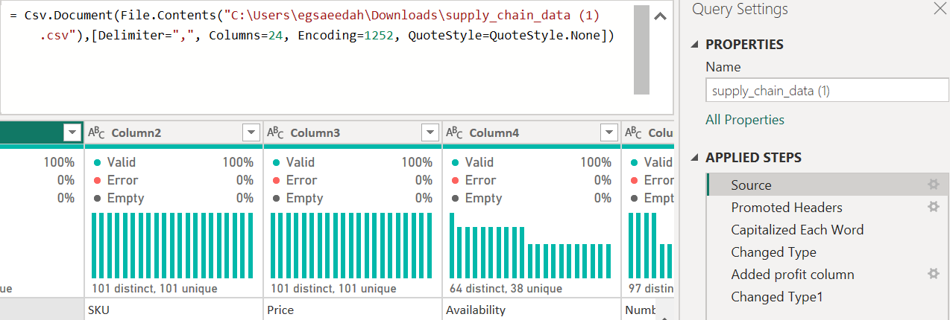

* Promoted first row as Header.
* Change data types of quantitative variables such as Price, Availability, and etc.

Note: The 'Revenue Generated' column may not exactly match the expected product of unit price and quantity sold.

2- Data Cleaning:

* Missing Values: Identify and handle missing data. Not have any missing values

All empty field 0% and 0% Error

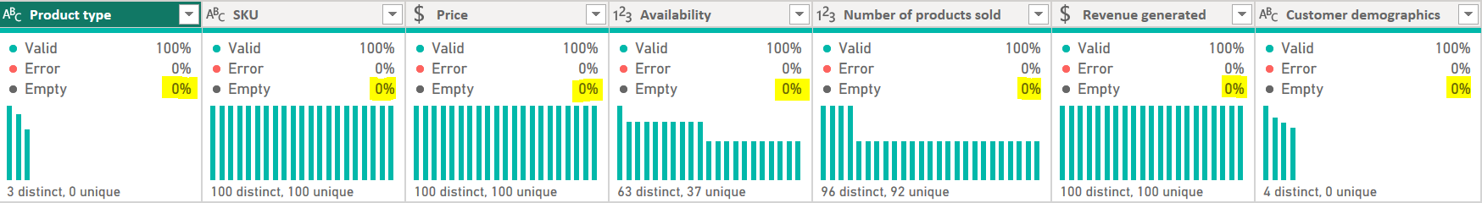

But the ‘Customer demography’ column contains unknown refers to a lack of information about gender identity.

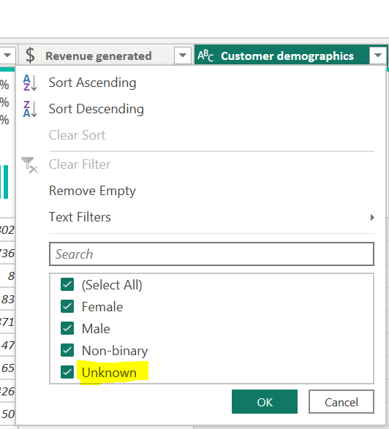

* Data Type: Verify that each column is classified with the appropriate data type (numeric, text, etc.).
* 3.Remove Replicate: Confirm SKU identifiers are unique.

* Data Require: Add Profit column =

revenue generated - (manufacturing costs + shipping costs + costs)

3- Descriptive Statistical Analysis:

* A diagram of a chart

  Description automatically generated with medium confidenceA blue and orange rectangular boxes

  Description automatically generated “5 Numbers” analysis: to check outliers for quantitative variables such as Price, Availability, and Revenue, etc. Not have any outliers

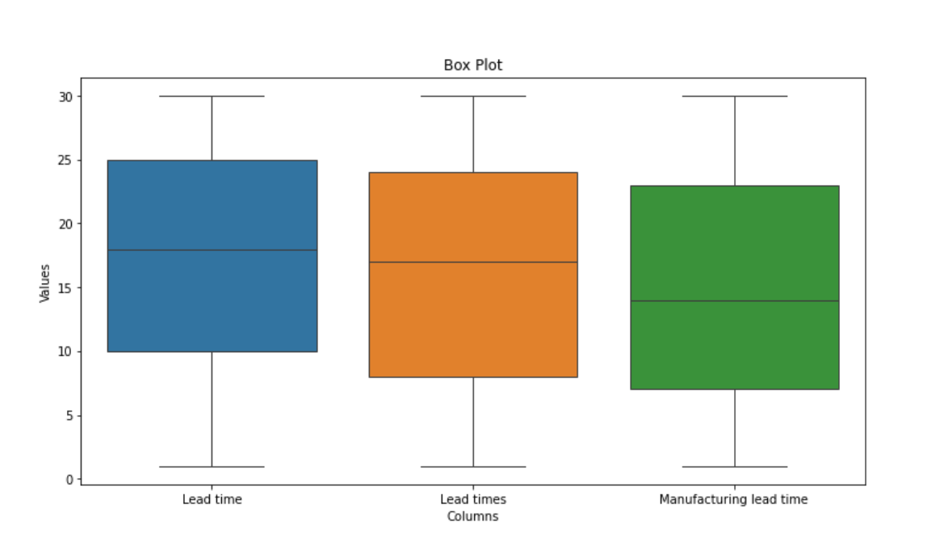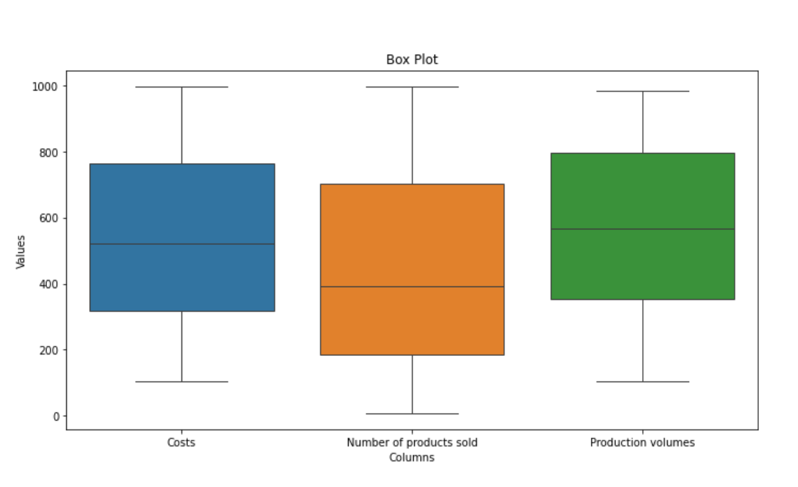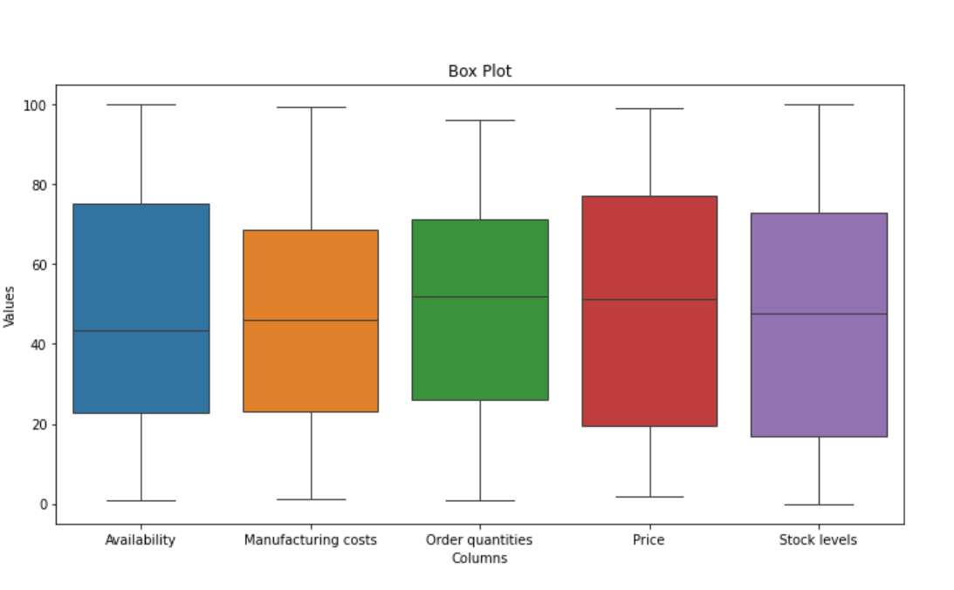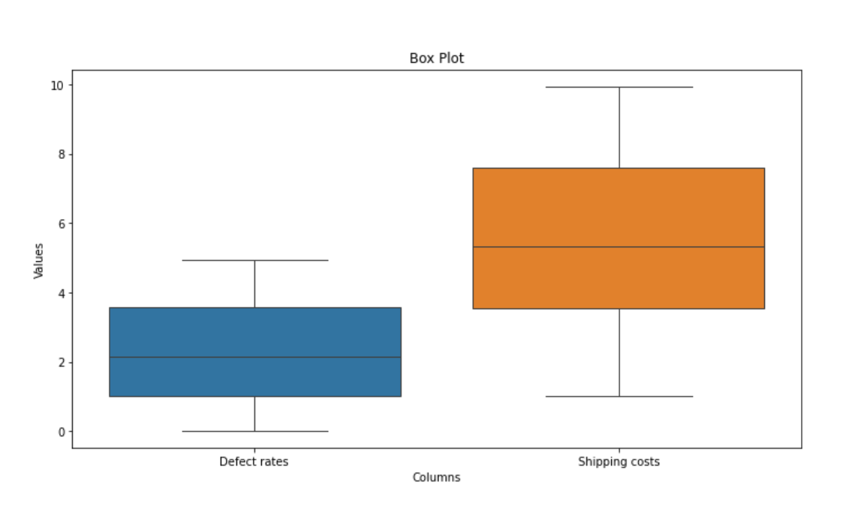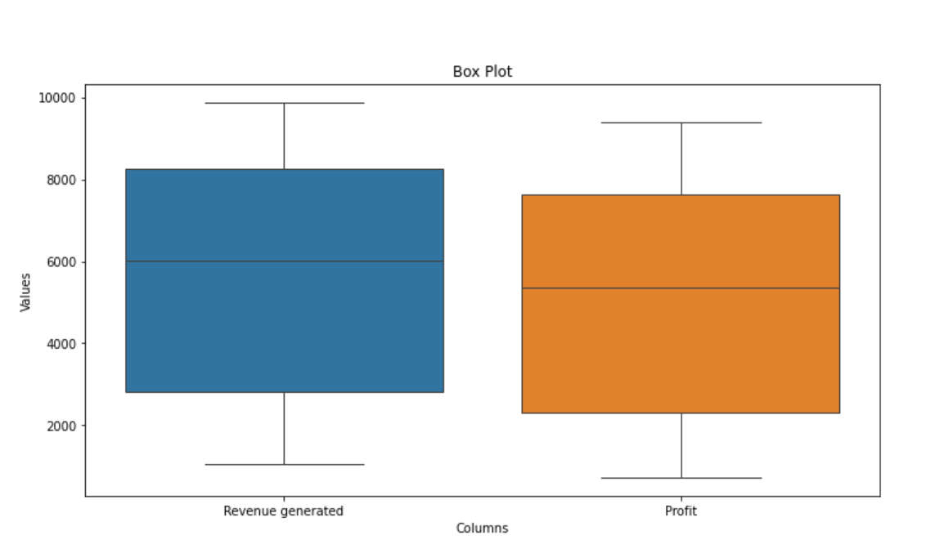

* Correlation Matrix: to check correlation between quantitative variables.

Most of correlation between quantitative variables from -0.3 to 0.3 it is mean not strong relationship between variables

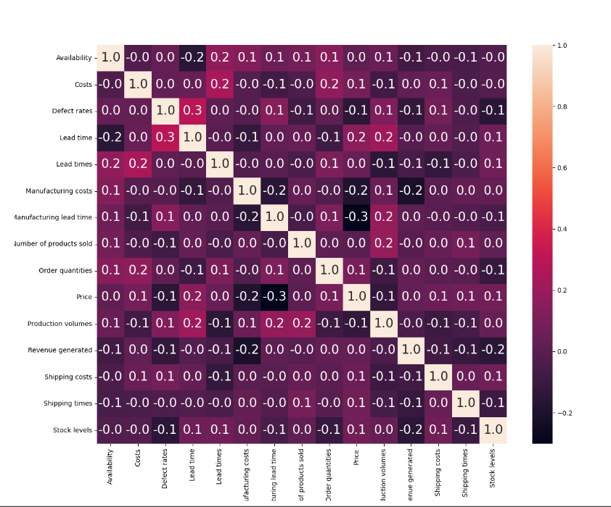

4- Data Normalization:

We classify these fields as a key to facilitate analysis

|  |  |  |  |
| --- | --- | --- | --- |
| **Product** | **Logistics** | **Manufacturing** | **Customer** |
| Product type | Shipping times | Production volumes | Customer demographics |
| SKU | Shipping carriers | Manufacturing lead time | Order quantities |
| Price | Shipping costs | Manufacturing costs | Location |
| Availability | Transportation modes | Inspection results |  |
| Stock levels | Costs | Defect rates |  |
| Revenue generated | Routes | Supplier name |  |
| Number of products sold | Lead times | Lead time |  |

* ***Analysis Questions Phase:***

We divide our project into 5 topics

- Sales Analysis   
- Customers Analysis   
- Logistics Analysis   
- Suppliers Analysis   
- Supply chain Analysis

And each topic has its own analysis questions that our analysis must be answer these

Sales Analysis

1.Identify top-selling products on profit.

2.Identify the impact of pricing on sales.

3.Identify products with high and low profitability

Customer Analysis

4.Identify customer purchasing behavior.

5.Identify customers demographics per location.

Supplier Analysis

6.Evaluate supplier performance based on product quality, lead time and defect rate in manufacturing.

7.Analyze product defection rates for each type and SKU.

Logistics Analysis

8.Evaluate the efficiency of different carriers, shipping routes and transportation modes.

Supply Chain Analysis

9.Evaluate the efficiency of orders fulfillment by track Lead Times and Manufacturing Lead Time for potential delays.

10. Evaluate the efficiency of orders fulfillment by compare orders QTY against availability and stock levels .

* ***Data Modeling Phase:***

In this phase we created some measures to build dashboards

**The measures we created :**

1. % Profit = divide(sum('supply_chain_data (1)'[Profit]),sum('supply_chain_data (1)'[Revenue generated]))

We used this measure to calculate the % profit from Revenue generated

1. Qty Required = sum('supply_chain_data (1)'[Number of products sold])+sum ('supply_chain_data (1)'[Order quantities])

We used this measure to define total quantity required (sold+ orders)

1. Sold vs volumes = divide(sum('supply_chain_data (1)'[Number of products sold]),sum('supply_chain_data (1)'[Production volumes]))

We used this measure to define ratio between sold and volumes

1. Stock keep in WH = AVERAGE('supply_chain_data (1)'[Lead times])- AVERAGE('supply_chain_data (1)'[Shipping times])

We used this measure to define how many days the order keep in warehouse waiting to ship

1. Unit ship cost = divide(sum('supply_chain_data (1)'[Shipping costs]),sum('supply_chain_data (1)'[Number of products sold]))

We used this measure to define shipping cost per unit shipped

* ***Dashboards phase:***

After that we build our dashboards that aims to understand the analysis questions

|  |  |
| --- | --- |
| Analysis questions | Answers |
| **Sales Analysis** | |
| 1-Identify top-selling products on profit. | Skincare products are the bestsellers 42 % of profit |
| 2-Identify the impact of pricing on sales. | Positive impact the price of product for skincare with price between 0 – 20 and 80 – 100 on Qty and Revenue. |
| 3-Identify products with high and low profitability | The highest profit comes from SKU2, SKU38, SKU67, SKU88, and SKU51, while the lowest revenue comes from SKU59, SKU78, , SKU86 , SKU91 and SKU75. |
| **Customer Analysis** | |
| 4-Identify customer purchasing behavior. | The highest revenue comes from "unknown" customers, followed by female, male, and non-binary.  Female are mainly purchased skincare and cosmetics vs haircare, while male are purchased skincare and haircare products vs cosmetics |
| 5-Identify customers demographics per location. | The highest revenue comes from Kolkata and Mumbai good selling markets. And New Delhi having lowest selling of products. |
| **Supplier Analysis** | |
| 6-Evaluate supplier performance based on product quality, lead time and defect rate in manufacturing | Supplier 1 the best all suppliers with the highest % pass.  Supplier 3 takes highest time in supplying materials than any other supplier especially ‘Cosmetics' items we may re-think before ordering Cosmetics item from supplier 3. |

|  |  |
| --- | --- |
| 7-.Analyze product defection rates for each type and SKU. | The defect rate of skincare and haircare higher than cosmetics, The highest defects comes from SKU42, SKU65, SKU1, SKU84, and SKU50 around 5% , while the defect average 2.3%. |
| **Logistics Analysis** | |
| 8-Evaluate the efficiency of different carriers, shipping routes and transportation modes | The lowest cost of shipping unit comes from carrier A, followed by carrier B and carrier C, while company shipped a lot of product by B.  The lowest cost of shipping unit comes from sea transportation, followed by other modes, although we shipped small of quantity. |
| **Supply Chain Analysis** | |
| 9.Evaluate the efficiency of orders fulfillment by track Lead Times and Manufacturing Lead Time for potential delays. | Skincare and cosmetics products have Lead Times more than Manufacturing Lead Time, while haircare products leads to potential delays. |
| 10-Evaluate the efficiency of orders fulfillment by compare orders QTY against availability and stock levels. | Higher availability and stock level indicates a more efficient and reliable supply chain. The company need to review SKU 33, SKU2, SKU9, etc. company has orders without available stock suitable. |

Summary / Recommendation to increase profitability

* Support sales of cosmetics.
* Improve quality of entry data for gender type.
* Spread distribution to cover all cites.
* Develop suppliers 3 and 4.
* Sync availability and stock level with demand.
* Avoid ship by Air as you can.
* Prefer carrier A for shipping.